FastTrack Architecture Reference – Power Platform Dataverse Dependency Validation
Microsoft FastTrack Reference Architecture for Dynamics 365 / Power Platform

Document Information
Author | Rita Abi Zeid – Power Platform / Dynamics 365 Technical Architect
Contributors | Solution Architect – Power Platform; DevOps Engineer – Power Platform ALM; Technical Lead – Power Platform Development
Reviewers | Customer Solution Architect
Approvers | Customer Project Manager; Customer IT Manager
Version | 1.0
Status | Final
Confidentiality | Customer Confidential

Version History
Version | Date | Author | Description
1.0 | 2026-02-17 | Rita Abi Zeid | Initial FastTrack Architecture Reference

Executive Summary
This reference architecture describes a governance and validation approach to prevent deployment and runtime failures caused by missing Microsoft Dataverse field dependencies referenced from custom code (plugins, custom workflow activities, and external services). It introduces an automated pre-deployment validation layer in the CI/CD pipeline to detect missing columns before solution import. This improves deployment reliability, strengthens ALM governance, and aligns with FastTrack expectations for Dynamics 365 nominations.

Architecture Objectives
• Prevent deployment of solutions with unresolved field dependencies
• Detect code-level dependency issues before production deployments
• Improve ALM governance and maturity with automated quality gates
• Reduce production incidents and user impact
• Ensure system reliability and auditability across environments

Background & Problem Statement
Dataverse provides strong built-in dependency tracking for metadata components (tables, columns, relationships, forms, views, apps, security roles, workflows). During solution export/import, missing metadata blocks deployment. However, when column logical names are referenced inside compiled C# code—for example, in plugins or custom workflow activities—Dataverse does not introspect assemblies and therefore cannot validate those references. If a referenced column is absent in the target environment, the solution may import successfully yet fail at runtime, causing errors such as "Attribute does not exist", blocked record saves, and business disruption.

Logical Architecture
• Developer Layer: plugin and solution development
• CI/CD Layer: build pipeline, static analysis, dependency validation engine
• Dataverse Layer: metadata repository and target environment
• Governance Layer: deployment gates and validation policies

Physical Architecture
• Azure DevOps or GitHub Actions
• Power Platform CLI (pac)
• Dataverse Web API / XrmTooling
• Static code analysis using Roslyn, regex scanning, or custom analyzers
• Managed solutions / plugin assemblies
• Target Dataverse environments (Dev/Test/PreProd/Prod)

Architecture Diagrams
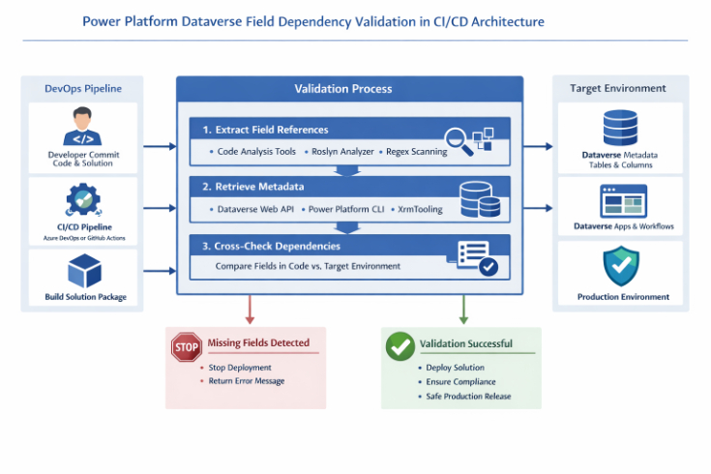
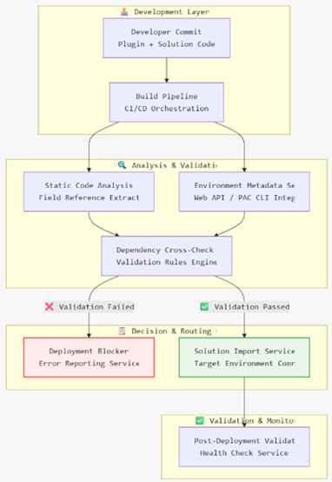

Proposed Validation Strategy (Pre-Import Gate)
Step 1: Extract Field References from Code
During CI/CD, parse plugin and workflow code to detect logical names used in GetAttributeValue<T>, Attributes["name"], QueryExpression filters, FetchXML, and early-bound entity properties. Implement via Roslyn analyzers, static analysis, regex scanning, or a custom build task.
Step 2: Retrieve Target Environment Metadata
Use Dataverse Web API / pac CLI to retrieve table and column metadata (logical names) from the target environment.
Step 3: Cross-Check & Enforce
Compare referenced fields from code against the target environment metadata. If any are missing, fail the pipeline and block solution import with a clear error message listing missing columns and tables.

ALM Governance Integration
• Introduce the validation as a mandatory gate before solution import
• Run after solution export and solution checker, within automated quality checks
• Log and archive validation artifacts for audit (build logs, reports)
• Treat failures as release blockers with remediation guidance

Best Practices
• Package dependent metadata and plugins in the same managed solution
• Avoid hard-coded logical names—prefer early-bound classes or centralized constants
• Include defensive checks (entity.Contains("logicalname")) to avoid crashes, without replacing validation
• Run Solution Checker to raise overall quality even if it does not detect code-level field gaps

Architecture Flow
• Developer commits code and solution components
• CI/CD pipeline triggers build
• Static analysis extracts field references from code
• Pipeline retrieves target environment metadata
• Dependency cross-check runs and generates a report
• If validation fails → deployment blocked; if passes → solution import continues

Benefits
• Increased deployment reliability and predictable releases
• Reduced production incidents and user disruption
• Higher ALM maturity and improved governance posture
• Compliance through auditable, automated quality gates

Conclusion
By implementing a pre-import dependency validation phase within the CI/CD pipeline, organizations close the gap between metadata-level dependency checks and code-level field references. This FastTrack-aligned architecture minimizes deployment risk for Dynamics 365 and Power Platform solutions and supports nomination criteria for enterprise-scale reliability.

Implementation Appendix

Sample Azure DevOps YAML
stages:
- stage: Validation
jobs:
- job: FieldDependencyValidation
steps:
- task: PowerPlatformToolInstaller@2
- script: |
dotnet run Analyzer.dll
pac table list --environment ${{ variables.environment }}
- task: PublishBuildArtifacts@1
condition: failed()

Sample Roslyn Rule Snippet
if (invocation.Expression.ToString().Contains("GetAttributeValue"))
{
var logicalName = ExtractStringLiteral(invocation);
ReportIfMissing(logicalName);
}

